Experiment-2

NAME: SHALINI R K ROLL NO:230701304
Design a UI where users recall visual elements (e.g., icons or text chunks). Evaluate the effect of chunking on user memory.
FRAME 1:
INSTRUCTION PAGE:

Chunking Analysis of the Instruction Page
Chunking is a cognitive strategy that breaks down information into smaller, manageable units,
making it easier to process and retain. The Memory Recall Task instruction page effectively utilizes chunking in the following ways:

Clear and Sequential Numbering
  - The instructions are broken down into six steps, making it easier to follow.
  - Each step presents one key action in a structured manner, reducing cognitive overload.

Logical Grouping of Information
  - Observation Phase (Steps 1-2) → Users learn about what they will see.
  - Memorization Strategy (Step 3) → Encourages users to focus on remembering items.
  - Recall Phase (Steps 4-5) → Explains how users will recall information.
  - Key Performance Metric (Step 6) → Highlights that accuracy matters more than speed.

Visual Hierarchy and Design Elements
  - Bold, large title ("MEMORY RECALL TASK") → Grabs attention and clearly states the task.
  - Bullet points and spacing → Reduce clutter, enhancing readability.
  - Highlighted "START" button → Signals the next step, keeping navigation intuitive.
  - Bee-themed visuals → Add a playful touch, engaging users without distraction.

Time Constraint Reinforcement
  - Step 5 explicitly states, “You will have 5 seconds to view the items.”
  - This reinforces expectations while subtly urging users to focus.

Simplicity and Clarity

  - Instructions use short, direct sentences, avoiding unnecessary complexity.
  - The active voice makes it more engaging and action-oriented.

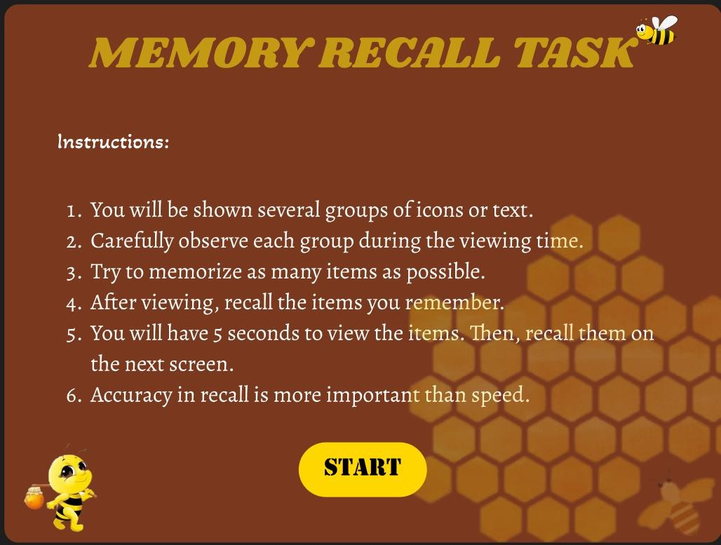
FRAME 2:
CHUNKING PHASE:

Analysis of the Memory Recall Task - Chunking Phase Screen
This screen represents the Chunking Phase of a Memory Recall Task, where users observe and memorize different icons within a limited time. Below is a breakdown of its key components:

Purpose of the Screen
  - This is the visual memory encoding phase, where users view and group items mentally
before recalling them.
  - The term "Chunking Phase" suggests that the game applies the chunking principle, which helps users remember items by categorizing them into meaningful groups.

Key Elements and UI Components

⏳ Countdown Timer (Top Left - Red Circle: "00:05")
  - Indicates that users have 5 seconds to observe and memorize the displayed items.
  - The bright red color and bold text create urgency, ensuring users stay focused.

Progress Bar (Pink Bar Below Title)
  - Shows the time remaining visually, reinforcing the sense of urgency.
  - A partially filled bar suggests that some time has already passed.

Grid of Icons
  - Various icons (such as a pig, burger, clock, police car, arrow, snowman, bee, laughing emoji, etc.) are displayed in a 5x4 grid format.
  - These icons are visually distinct yet grouped by similarities, encouraging chunking strategies like:
    - Categorizing by theme (e.g., animals, food, transportation).
    - Grouping similar colors or backgrounds (e.g., pink, blue, or yellow tiles).
    - Associating repeated icons (e.g., multiple bees, burgers, police cars).
🐝 Bee Character Holding a Scroll (Top Right)
  - Acts as a friendly mascot, enhancing engagement and giving a playful theme.
  - The scroll may imply instructions or guidance in later stages.

How the Chunking Phase Works
- Users scan the grid and look for patterns or related items to create mental chunks.
- The countdown timer limits observation time, forcing quick memory strategies.
- Once time is up, users transition to the recall phase, where they must identify previously seen items.

Cognitive and UX Benefits of Chunking
  - Enhances short-term memory by allowing users to recall groups of information instead of individual elements.
  - Reduces cognitive overload by helping users organize data efficiently.
  - Improves pattern recognition, making recall easier and more accurate.

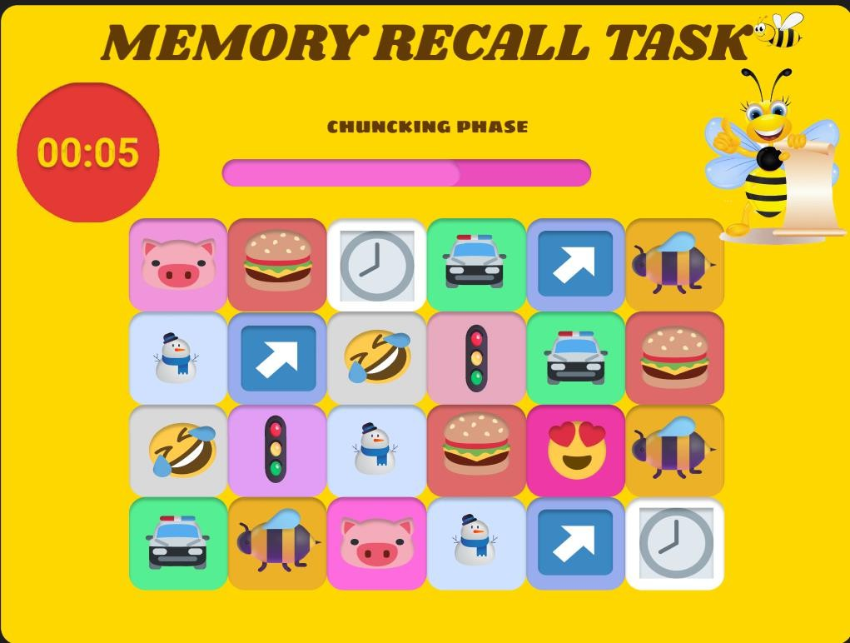
FRAME 3:
RECALL PHASE:

Analysis of the Memory Recall Task - Selection Phase
This screen represents the Selection Phase of a Memory Recall Task, where users recall and choose the items they remember from the previous Chunking Phase. Below is a breakdown of its
components:

Purpose of the Screen
  - This is the memory retrieval stage, where users select the items they remember seeing in the previous phase.

The goal is to test the effectiveness of chunking and short-term memory retention.

Key Elements and UI Components
📝 Title & Instructions
  - "MEMORY RECALL TASK" (Bold Header) – Reinforces the purpose of the task.
  - "SELECT THE ITEMS YOU REMEMBER:" – Clear instruction guiding the user to choose remembered items.

Grid of Icon Choices
  - A set of eight icons are presented as multiple-choice options.
  - Some icons were previously displayed, while others are distractors (new icons added to confuse users).
  - Users must identify which icons appeared in the Chunking Phase.
  - Each icon has a radio button below it for selection.
□🐝 Animated Bee Character (Bottom Left)
  - The bee character reinforces a playful, engaging theme.
  - It may act as a mascot or guide throughout the memory task.

"SUBMIT" Button (Bottom Center)
  - Once users have made their selections, they press "SUBMIT" to confirm their recall choices.

How the Selection Phase Works
- Users analyze the displayed icons and recall which ones they saw in the Chunking Phase.
- They select the remembered icons using the radio buttons below each option.
- Some icons are distractors, testing whether the user’s memory is accurate or if they mistakenly recall incorrect icons.
- Clicking "SUBMIT" finalizes their choices, leading to a results or feedback screen.

Cognitive and UX Benefits
  - Tests memory accuracy by comparing user selections with previously displayed items.
  - Incorporates distractors to evaluate how well users distinguish real vs. false memories.
  - User-friendly interface with clear selection mechanics (radio buttons).
  - Gamified elements (bee character, bright colors) make the task engaging.

-

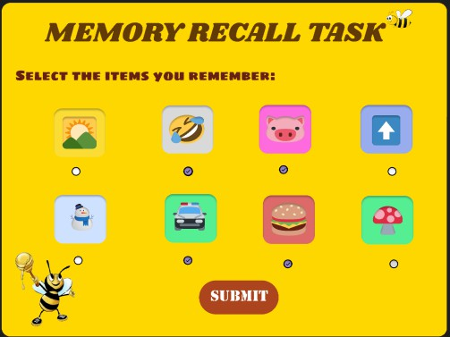
FRAME 4:
RESULT PAGE:

Analysis of the Memory Recall Task - Score & Feedback Screen
This screen represents the Score & Feedback Phase of the Memory Recall Task, where users receive their performance evaluation based on the selections made in the previous Recall Phase.

Purpose of the Screen
  - Provides feedback on recall accuracy by showing the number of correct answers.
  - Allows users to decide their next action (continue, restart, or exit).

Key Elements & UI Components
📝 Title & Score Display
  - "MEMORY RECALL TASK" – Reinforces the game’s title.
  - "YOUR RECALL SCORE!" – Indicates that the user’s performance is being displayed.
  - A wooden scoreboard with the user’s score (4/5) in bold, showing correct answers out of total attempts.

Action Buttons (Right Side)
  - "CONTINUE" – Proceeds to the next level or stage.
  - "RESTART" – Allows the user to retake the memory recall test.

  - "EXIT" – Ends the task and exits the game.
🐝 Animated Bee Character (Bottom Left)
    - The bee character adds a playful, gamified element.
    - Holds a blank sign, possibly for dynamic messages or additional instructions.

How This Phase Works
- The game evaluates the user’s selections from the Recall Phase.
- It calculates the accuracy score (4/5 in this case) and displays it on a wooden board.
- Users review their performance and choose their next action:
  - Continue if they want to proceed.
  - Restart if they want to improve their recall.
  - Exit if they want to stop playing.

Cognitive & UX Benefits
  - Instant feedback helps users track their memory performance.
  - Multiple options (Continue, Restart, Exit) give users control over their learning experience.
  - Visual & gamified elements make the task engaging and less stressful.

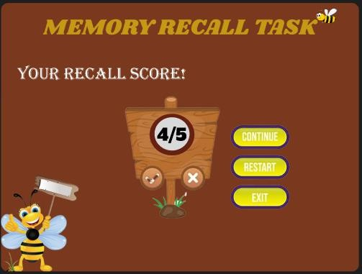

PROTOTYPE LINK:
https://www.figma.com/proto/6zpZCiEwaGL4noMI7Y3w1R/chunking?page-id=0%3A1&node-id=2-2&p=f&viewport=-252%2C293%2C0.39&t=5TdEQelKQZq9mxCS-1&scaling=scale-down&content-
scaling=fixed&starting-point-node-id=2%3A2

